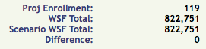

Teachers

Green = WSF Blue = Fed Funds

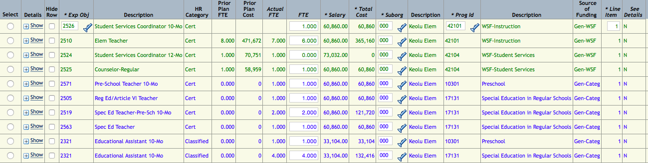

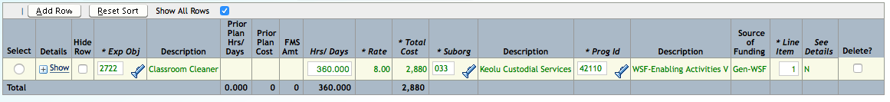

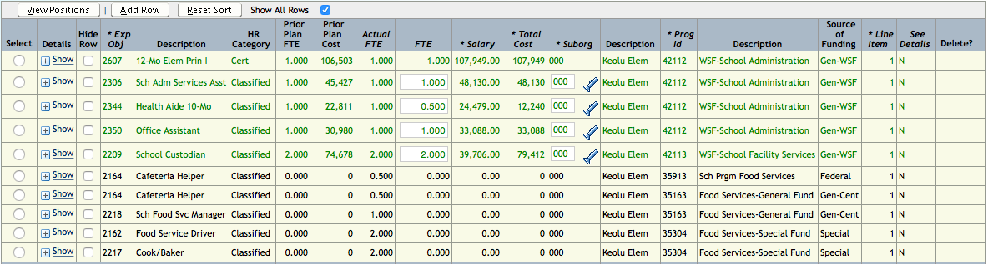

Staff Support

Green = WSF Blue = Fed Funds

Operational Funds Green = WSF Blue = Fed Funds

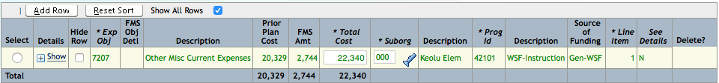

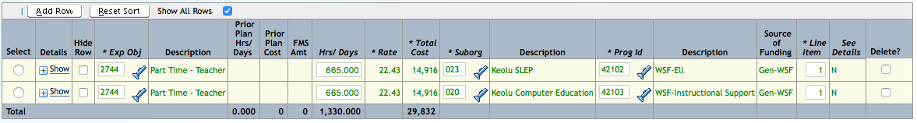

Part Time Teachers

Green = WSF Blue = Fed Funds