~ Keolu Elementary ~
Academic Plan
SY 2021 - 2022
Academic Plan
SY 2021-2022
Draft#1
April 1, 2021

Keolu Elementary, 1416 Keolu Drive, Kailua, HI 96734
808.266.7818
http://keoluelementary.com/

Academic Plan, School Year 2021- 2022

School: Developing a collaborative Academic Plan framed by the HIDOE Learning Organization is the foundation for a forward focused Academic Plan.
An effective Academic Plan utilizes existing school resources to improve and/or introduce new ideas that accelerate the school community’s knowledge about ending achievement gaps and providing equitable services for all students. A forward focused Academic Plan clearly describes a school’s Theory of Action that incorporates the following: 1) analyzing data to explain achievement gaps; 2) incorporating measurable outcomes that inform a school how to close an achievement gap; and 3) applying contextual and community measurements and assessments.
Starting from a comprehensive needs assessment, schools design measurable outcomes from the study of organizational, instructional, and student support systems. The measurable outcomes are implemented and improved through Plan, Do, Check, Act (PDCA) cycles and systemized by leading indicators.

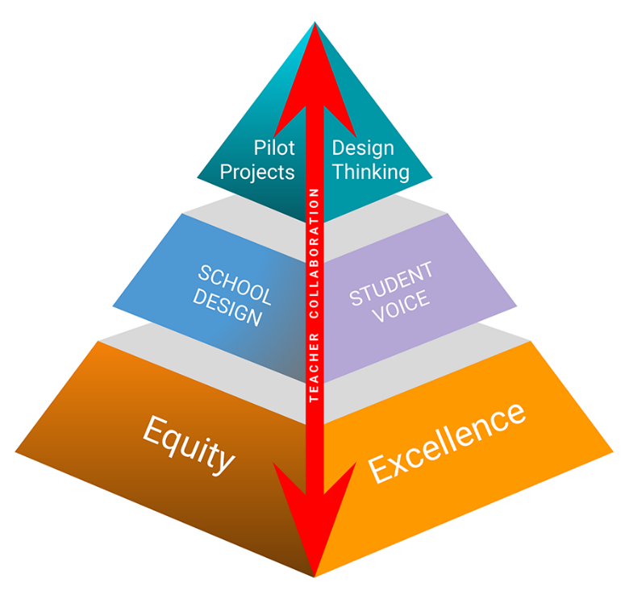
HIDOE Learning Organization
Pipeline of Emerging Ideas: To prepare for emerging trends, advancements and changes that impact education,
ideas are tried and vetted by our schools and teams, some will advance to support the core.
- The Pipeline of Emerging Ideas is linked to the HIDOE 2020-30 Strategic Plan
(page 5).
  - Innovation in Support of the Core: New strategies and systems for delivering teaching and learning. High-Impact strategies: School Design, Teacher Collaboration, Student Voice.
  - The Academic Plan incorporates School Design and Student Voice for Innovation in Support of the Core (pages 3-4).
  - Teaching & Learning Core: Focus: equity and excellence in core curriculum and supports.
  - The Academic Plan is structured by the HIDOE Learning Organization, and it is founded on the Teaching & Learning Core (page 2).

Principal: Gay Kong Date: April 1, 2021

Complex Area Superintendent: Lanelle Hibbs
Complex Area Superintendent’s signature and date

Goal 1: Improve Learning Environment to Support the Whole Child
School Data: Panorama Results fall 2020 Panorama Site SEL SURVEY CNA GLO's
Actions | Goal | Monitoring our Progress | Resources/Funding Source
a.) Survey parents to gather information about:  - Strengths and gifts that they are willing to share with our students/school.  - Needs and barriers that prevent them fully engaging in their child’s education.  - Their preferred method of communication: email, text, website, phone call, hard copy notes.  CNA: SQS section | By May of 2022  A minimum of 20% Increase parent engagement and reciprocal communication as measured against the survey that was sent home in the month of August 2021. | August, 2021: Send survey out  September, 2021: Parent Engagement committee: Reviews surveys and creates an action plan to increase:  - Parent engagement  - Parent Reciprocal Communication  - Monitoring system to measure our growth.  October – May, 2021: Implement family engagement activities (at least 3 per year) | Funding Source: Title One  -PCNC (PPE NID)  - Website Coordinator (PTT)  - Teacher planning time for events  (PTT pay)  -Materials/Supplies/  -Equipment/Digital Programs for  school-wide events and digital  connectivity with parents.
b.) Strengthen students as “self-directed” learners by incorporating formative assessment practices across all content areas.  CNA: GLO's | Increase by 10% of students who recieve an “Always” or “Usually” for component of Self-Directed Learners. | The following data will be monitored for continued improvement:  - Lessons on self-control  - Student self-assessment of learning behavior.  - General Learner Outcomes | Funding Source: WSF  -Counselor  Funding Source: Title One  - Social Story Books  - Panorama Playbook
c. Utilize our current structures and practices to implement a multi-tiered system that identify struggling students early so that they may receive assistance quickly. | Eliminate special education referrals for students in grades 3-6*.  *students who have been at our school for 2 or more years. | Documentation of student team meetings that collaboratively develop a plan of action to support struggling students. | Funding Source: Title One  - Subs for teacher meeting time.  - PPE/PTT for instructional support  - Reading Intervention Program

Goal 2: Improve Teacher Efficacy
School Data: WASC Priorities CNA

Actions | Goal | Monitoring our Progress | Resources/Funding Source
a.) Continue the implementation of  the cycle of Professional Teaching  and Learning framework.  CNA pg. 20 | All teachers are implementing the Powerful Instructional Practice (PIP) as measured by walk-thru data. | Documentation of the following:  - Professional Development  - Professional Reading  - Peer Observations  - Collaboration Opportunities | Funding Source: Title One  -PTT and Sub pay for  - ILT planning.  - Teacher planning  - Professional Development  -Stipends for PD  -Professional Literature  -Digital Programs  -Supplies/Materials/  Equipment needed to implement:  - Cycle of Prof. learning.  - Curriculum Maps  - Core Curriculum  Funding Source: District Funds  -District Educational Specialist to provide PD in development of curriculum maps & implementation of PIP.
b.) Develop curriculum maps and guides for Math and Science.  Revisit our ELA maps for clarification and possible revisions.  WASC Priorities | All teachers will have developed curriculum maps for 3 /4 core content areas by the end of SY 21-22: ELA, Math and Science. | Documented Curriculum Maps and guides:  - End of Q1: Review of ELA Maps developed in SY 1920  - End of S1: Math  - End of S2: Science  .
c.) Provide training in the development of curriculum maps and guides.  WASC Priorities | Professional development provided for the development of all core curriculum maps and guides. | Documented training provided by district educational specialist:  - End of S1: Math  - End of S2: Science.

Goal 3: Improve Student Learning
School Data: Academic Performance Summary EL WIDA SCORES CURRENT BAS data CNA
Actions | Goal | Monitoring our Progress | Resources/  Funding Source
a.) Continue implementing the workshop framework and the  Lucy Calkins Units of Study. | 1.) SBA measures for ELA and Math  -Whole School: Increase proficiency by  20% in Math and ELA.  2.) MGP for Math & ELA  - Economically Disadvantaged: 5% increase  in students who receive a 50 or above MGP  score. (Goal: Math 55% /ELA 62%)  - Sped Students: At least 50% of the students  have a MGP score of 50 or greater.  3.) Wida Measures  -Increase of 10% of EL students  who make an increase in their overall score by  1 level (goal 53%)  *Identified Sub Groups: EL, SPED,  Economically Disadvantaged | 1.) Walk thru data reflects:  -Students working on their  individualized level  -Collaborative conversations  -Conferencing  -Independent reading practices  2.) The following data will be monitored for continued improvement:  -BAS & iReady growth for all  students and identified sub  groups*.  -GOLD assessment data for PS &  PK.  - Report card data | Funding Source: Title One  -Consumable Books  -Materials/Supplies/Equipment to implement Common Core Standards. (xerox costs, laminating material, paper, stickies, etc.)  -Literature Books  -Digital Programs  -PPT/PTT/PPE to:  - support instruction  - manage website  - manage digital devices, programs, and installation of operating systems.
b.) Provide access to a wide range of high quality literature* that
meets the needs of beginning readers, as well as pique the interest’of our adolescent and reluctant readers.
c.) Implement formative assessment practices that personalize learning and inform students of their progress in attainment towards grade level CCSS.
d.) Provide intentional and explicit instruction for all common core standards to close the learning gap.
e.) Incorporate developmentally appropriate practices for early learners and young adolescents.

f.) Infuse academic vocabulary in all content areas.
G.) Explore reading intervention programs for our most struggling students.

Academic Review Team Template

I.) IMPROVE LEARNING ENVIRONMENT TO SUPPORT THE WHOLE CHILD.
What is being monitored | Evidence Collection | Notes | Person(s) Responsible
Family Engagement  Reciprocal Communication | Family Engagment Team:  Reviews survey and creates an action plan to increase:  - Parent engagement  - Parent Reciprocal Communication  - Monitoring system to measure impact of our actions. |  | Family Engagement Team:  - PCNC  - Counselor  - 1-2 teachers
Student Self Regulation Skills  Self Directed Learner. | Record GLO data for Semester 1  Review and discuss implications.  Share Panorama Playbook activities/strategies for improving student self regulation and self directed learner. |  | Student Learning Readiness Team  - Counselor  - SSC  - Lower grade teacher  - Upper grade teacher  - Sped Teacher
Implementation of MTSS | Documentation of early interventions for struggling learners. |  | SSC
II.) IMPROVE TEACHER EFFICACY
What is being monitored | Evidence Collection | Notes | Person(s) Responsible
Cycle of professional teaching and learning. | Documentation of one cycle that includes:  - Professional Learning using a mentor text.  - Teacher- teacher observations and feedback  - Teacher Reflection of instructional practices. |  | ILT
Completion of curriculum maps for math and science | Documentation of:  - Professional Learning  - Math and science curriculum maps. |  | ILT
III.) IMPROVE STUDENT LEARNING
What is being monitored | Evidence Collection | Notes | Person(s) Responsible
Workshop Model | Walk -Thru Data |  | ILT
Formative Assessment Practices | Walk -Thru Data |  | ILT
Explicit and Intentional instruction | Walk -Thru Data |  | ILT
Access to wide range of literature | Classroom libraries and school wide library contain wide range of reading material. |  | Principal
Infuse academic vocabulary | Word charts that are co-created by students and teacher. |  | ILT
Explore reading intervention programs. | Documentation of teacher meetings for the purpose of reviewing, assessing, and selecting a reading intervention program. |  | Principal

